Working Backward Poster A
Make 4 columns on your poster. (Name, Solid Figure, Volume Formula, Show work.)
Cut out an Glue the pictures below in Column 2.
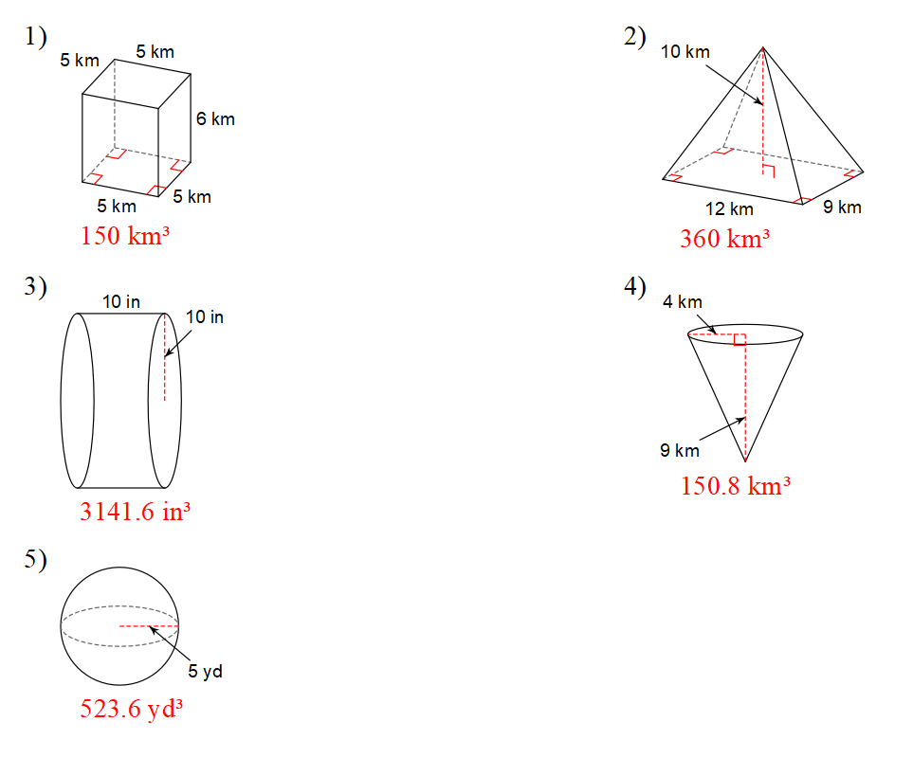
In the last column, show all work for finding the missing value.

V = ?
h = ?
r = ?
h = ?
h = ?
h = ?

Working Backward Poster B
Make 4 columns on your poster. (Name, Solid Figure, Volume Formula, Show work.)
Cut out an Glue the pictures below in Column 2.
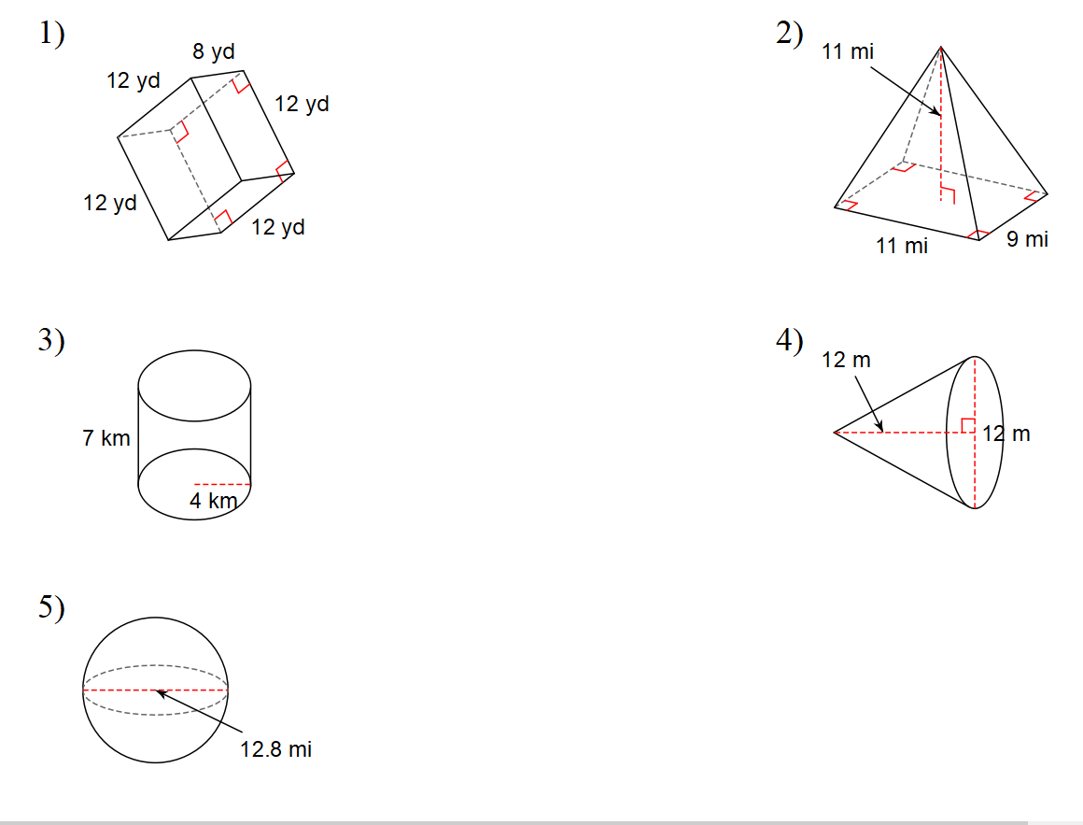
In the last column, show all work for finding the missing value.
V = ?
V = ?
V = ?
V = ?
V = ?

